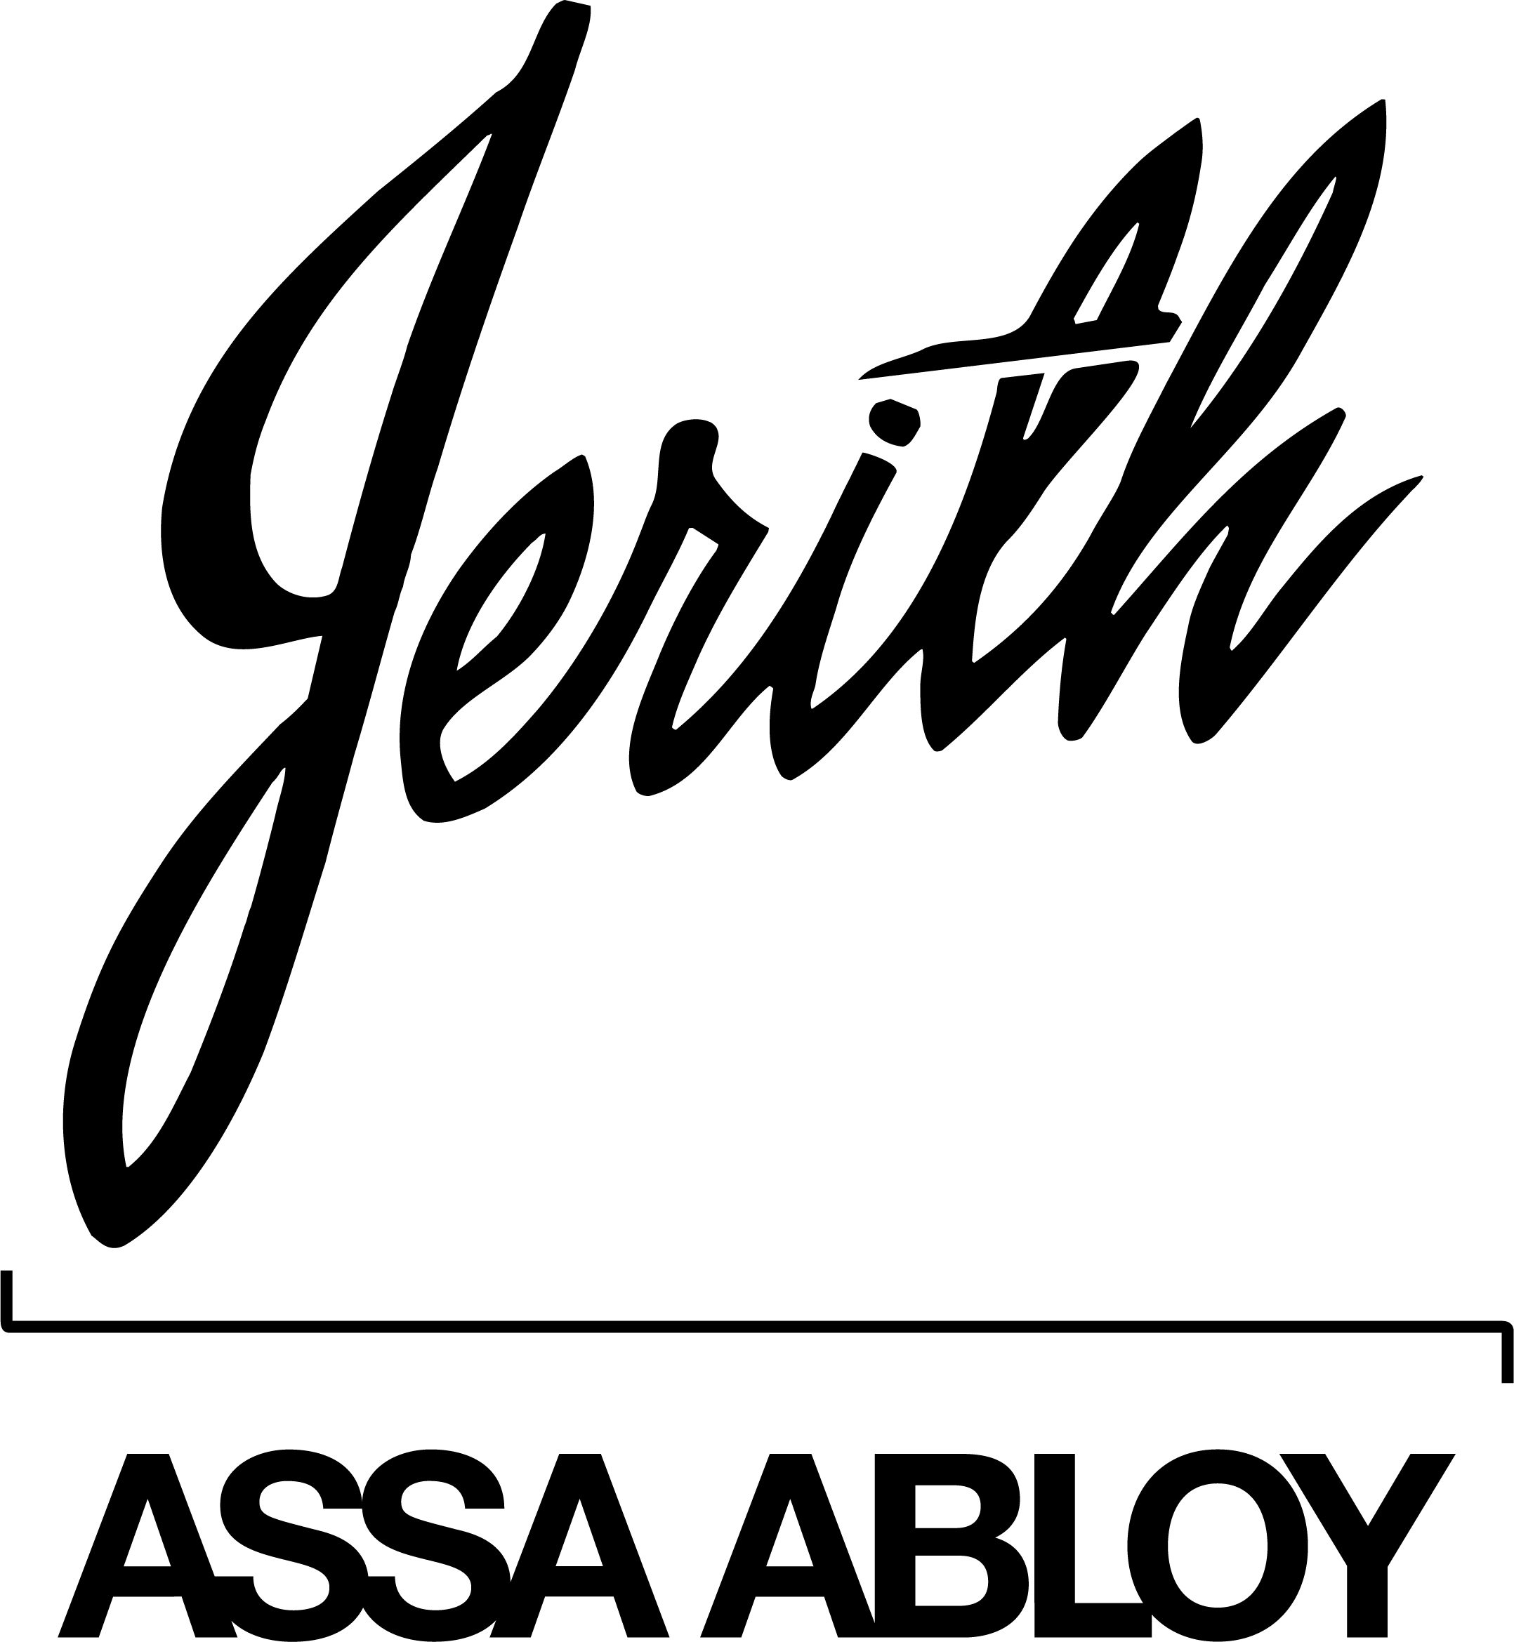
Industrial Aluminum Fence Specifications:
[This specification contains options and notes in square brackets. The various choices relate to the color, style, size, and component dimensions of the fences. Select one of the options and eliminate the brackets in your final specifications.]
Section 32 31 19 – Decorative Metal Fences and Gates
PART 1 – GENERAL:

  - SECTION INCLUDES
A. Decorative aluminum fencing, gates, and accessories

1.02 RELATED SECTIONS
A. Section __ __ __ - Earthwork

B. Section __ __ __ - Concrete

1.03 SYSTEM DESCRIPTION
A. The manufacturer shall supply a total ornamental aluminum fence system of the style, strength, size, and color defined herein. The system shall include all components (pickets, posts, rails, gates, hardware, and accessories) as required, and shall be fabricated, coated, and assembled in the United States.

1.04 QUALITY ASSURANCE
A. The contractor shall provide laborers and supervisors who are familiar with the type of construction involved, and the materials and techniques specified.

B. Manufacturer of fence system must have ten (10) years of documented experience in manufacturing the products specified in this section.

1.05 REFERENCES
A. AAMA 2604 – Voluntary Specification, Performance Requirements and Test Procedures for High Performance Organic Coatings on Aluminum Extrusions and Panels

B. AAMA 2603 – Voluntary Specification, Performance Requirements and Test Procedures for Pigmented Organic Coatings on Aluminum Extrusions and Panels

C. ASTM B117 – Practice for Operating Salt Spray (Fog) Apparatus

D. ASTM D2247 – Standard Practice for Testing Water Resistance of Coatings in 100% Relative Humidity

E. ASTM B221 – Specification for Aluminum Alloy Extruded Bars, Shapes, and Tubes

F. ASTM B85 – Standard Specification for Aluminum-Alloy Die Castings

1.06 SUBMITTALS
A. Manufacturer’s submittal package shall be provided prior to installation.

B. Changes in specification may not be made after the bid date.

C. Samples – if requested, samples of assembled materials, components, hardware, accessories, and/or color samples.

1.07 PRODUCT DELIVERY, STORAGE AND HANDLING
A. Upon receipt, materials should be checked for damage that may have occurred in shipping to the job site.

B. Each package shall bear the name of the manufacturer.

C. Store products in manufacturer’s unopened packaging.

D. Store materials in a secure and dry area to protect against damage, weather, vandalism, and theft.

E. Transport, handle and store products with care to protect against damage before installation.

PART 2 – PRODUCTS:

2.01 MANUFACTURER
A. The fencing system shall be Industrial Strength Aluminum Ornamental Fence as manufactured by Jerith Manufacturing LLC, 14400 McNulty Road, Philadelphia, PA 19154. Telephone: 800-344-2242; Fax: 215-676-9756; email: sales@jerith.com.

B. Substitutions: [Not Permitted / May be submitted in accordance with Section __ __ __ ].

C. Fencing system shall be Jerith Style # [100, 101, 111, 200, 202, 401, 402].

D. Fence height shall be [3, 4, 5, 6, 7, 8] feet.

E. Color shall be [Black, White, Green, Bronze].

2.02 MATERIALS
A. Aluminum Extrusions: All posts and rails used in the fence system shall be extruded from HS-35™ aluminum alloy having a minimum yield strength of 35,000 psi. All pickets shall have a minimum yield strength of 25,000 psi. 6063-T5 and 6063-T52 Alloys (in accordance with ASTM B221) are not acceptable for any components.

B. Fasteners: All fasteners shall be stainless steel. Square drive screws shall be used to connect the pickets to the horizontal rails. Rail to post connections shall be made using self-drilling hex-head screws.

C. Accessories: Aluminum sand and die castings shall be used for all scrolls, post caps, finials, and miscellaneous hardware. Die castings shall be made from Alloy A360.0 as per ASTM B85 for superior corrosion resistance. Alloy A380.0 is not acceptable.

2.03 FINISH
A. Pretreatment: A three stage non-chrome pretreatment shall be applied. The first step shall be a chemical cleaning, followed by a water rinse. The final stage shall be a dry-in-place activator which produces a uniform chemical conversion coating for superior adhesion.

B. Coating: Fence materials shall be coated with FencCoat™, a Super-Durable TGIC polyester powder-coat finish system applied by Jerith Manufacturing LLC. Epoxy powder coatings, baked enamel or acrylic paint finishes are not acceptable. The FencCoat finish shall have a cured film thickness of at least 2.0 mils. In addition, any screw heads shall be painted to match the color of the fence.

C. Tests: The cured FencCoat finish shall meet or exceed AAMA 2604, which includes the following requirements:
1. Humidity resistance of 3,000 hours using ASTM D2247.
2. Salt-spray resistance of 3,000 hours using ASTM B117.
3. Outdoor weathering shall show no adhesion loss, checking or crazing, with only slight fade and chalk when exposed for 5 years in Florida facing south at a 45 degree angle.

D. Finishes which only meet AAMA 2603 (or the previous version - AAMA 603) are not acceptable.

2.04 FABRICATION
A. Horizontal rails shall be 1⁵/₈” channels formed in a modified “U” shape. Pickets shall pass through holes punched in the top of the rail. The top wall shall be .070” thick and the side walls .100” thick for superior vertical load strength. There shall be 3 horizontal rails (4 rails for 8' high fence) in each section.

B. Pickets shall be fastened to the rails using painted stainless steel screws. Screws shall be used on only one side of the rail, leaving the other side with a clean appearance. Pickets shall be 1” square and have a wall thickness of .062”. Welding the pickets to the rails is not permitted.

C. Posts shall be 2½” square extrusions with pre-punched holes which allow the fence section rails to slide in. Posts shall be spaced 71½” on center and have .075” walls. Gate posts shall be [4” or 6”] square with .125” walls and used on both sides of a gate. Die cast aluminum caps shall be provided with all posts.

D. Cantilever slide gates shall be fabricated according to manufacturer's standard methods. Swing gates shall have welded frames and shall support a 300 lb. vertical load on the latch side of the gate without collapsing. Walk gates shall be self-closing and self-latching.

E. Assembled sections shall support a 1,000 lb. vertical load at the midpoint of any horizontal rail.

F. The Jerith logo shall appear on all post caps, gates, and horizontal rails of the fencing system.

2.05 WARRANTY
A. The entire fence system shall have a written Limited Lifetime Warranty against rust and defects in workmanship and materials. In addition, the FencCoat finish shall be warranted not to crack, chip, peel, or blister for the same period.

PART 3 – EXECUTION:

3.01 PREPARATION
A. Verify areas to receive fencing are completed to final grades and elevations.

B. Ensure property lines and legal boundaries are clearly established.

C. Prepare the grade and remove any surface irregularities which may cause interference with the installation of the aluminum fence.

3.02 FENCE INSTALLATION
A. Install fence in accordance with the manufacturer’s instructions.

B. Excavate post holes to proper depth to suit local conditions for stability and support of the fence system without disturbing the underlying materials. Excavate deeper as required for adequate support in soft and loose soils.

C. Set fence posts in concrete footers at 71-1/2” on center maximum. For installations on a slope, the post spacing must be measured along the grade.

D. Insert notched horizontal rails in pre-punched holes in post and fasten in place.

E. Center and align posts in holes to required depth. Place concrete around posts and tamp for consolidation. After tamping, check alignment of posts, and make necessary corrections before the concrete hardens.

3.03 GATE INSTALLATION
A. Set gate posts plumb and level for gate openings specified in construction drawings.

B. Install gates to allow full opening without interference after concrete has hardened around gate posts. Adjust hardware for smooth operation. Install one drop rod for double gates.

3.04 ACCESSORIES
A. Install post caps and other accessories to complete fence.

3.05 CLEANING
A. Contractor shall clean site of debris and excess materials. Post hole excavations shall be scattered uniformly away from posts.

B. If necessary, clean fence system with mild household detergent and clean water. Excess concrete must be removed from posts and other fencing material before it hardens.

